Exercise 1: Setting Up Junit
Scenario : You need to set up JUnit in your Java project to start writing unit tests.

1. Created a New Maven Project in IntelliJ
- Opened IntelliJ IDEA → File → New Project.
- Selected Maven and provided:
  - GroupId: com.example
  - ArtifactId: Junit_Testing
- Chose the default location and finished creating the project
2. Added JUnit Dependency in pom.xml
- Opened the pom.xml file.
- Added the following inside the <dependencies> tag to include JUnit 4:
<dependency>
<groupId>junit</groupId>
<artifactId>junit</artifactId>
<version>4.13.2</version>
<scope>test</scope>
</dependency>
- Reloaded Maven to download the dependencies.
3. Created Application Code (Calculator.java)
- Navigated to src/main/java/com/example.
- Created a new class: Calculator.java
package com.example;
public class Calculator {
public int add(int a, int b) {
return a + b;
}
}
4. Created Test Package and Class (CalculatorTest.java)
- Navigated to src/test/java.
- Right-clicked and created a new package: com.example.
- Inside that package, created a new Java class: CalculatorTest.java.
package com.example;
import org.junit.Test;
import static org.junit.Assert.assertEquals;
public class CalculatorTest {
@Test
public void testAdd() {
Calculator calc = new Calculator();
int result = calc.add(3, 4);
assertEquals(7, result); // Test passes
}
}
5. Verified the Project Structure

Junit_Testing/
├── src/
│ ├── main/java/com/example/Calculator.java
│ └── test/java/com/example/CalculatorTest.java
├── pom.xml

6. Ran the Test
- Right-clicked CalculatorTest.java → Selected Run 'CalculatorTest'.
- The test executed successfully with a green checkmark.

Final Outcome:
Case 1: Test PASSED
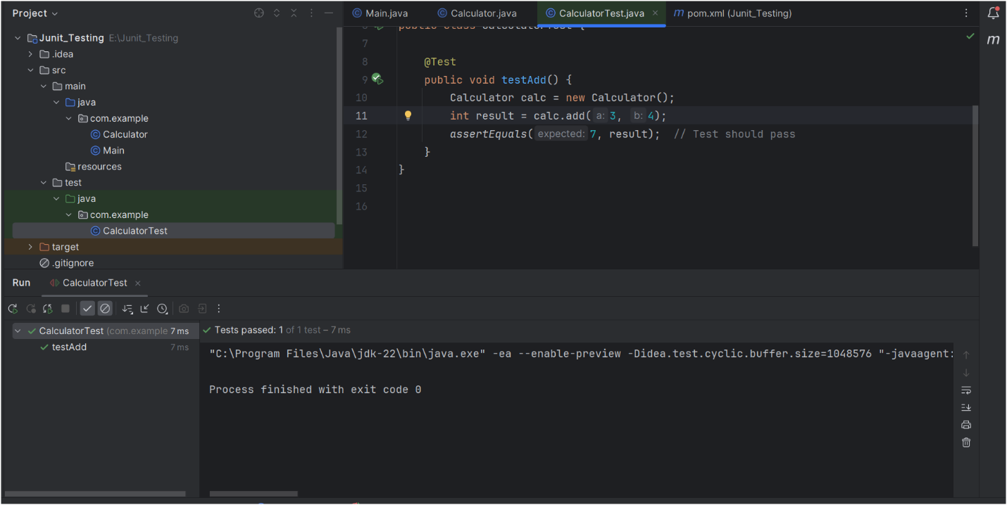

Case 2: Test FAILED
